**Name: Sreelekshmi Anilkumar**

**Roll No: 42**

**Batch: RMCA**

**Date: 25-03-2022**

**ADVANCED DBMS LAB**

**Experiment No.: 1**

**Aim**

Practice CRUDE operations in mogodb

**Procedure:**

**Creating a Collection**

If the collection does not currently exist, insert operations will create the collection.

Code:

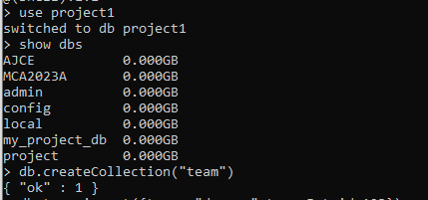

## Insert a Single Documen

Insert a single document into the collection

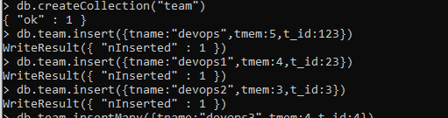

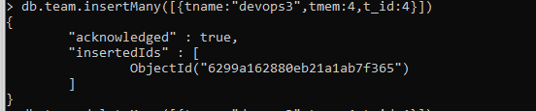

Delete single document into the collection



Update single document into the collection

